**SOFTWARE TESTING WITH SELENIUM**

**727721EUCS024**

**DHAKSHINYA C A**

**DAY 5**

**EX1**

package com.Pack1;

import org.openqa.selenium.By;

import org.openqa.selenium.WebDriver;

import org.openqa.selenium.WebElement;

import org.openqa.selenium.chrome.ChromeDriver;

import org.openqa.selenium.chrome.ChromeOptions;

import org.openqa.selenium.interactions.Actions;

import io.github.bonigarcia.wdm.WebDriverManager;

public class day51 {

public static void main(String[] args) {

WebDriverManager.chromedriver().setup();

ChromeOptions co=new ChromeOptions();

co.addArguments("--remote-allow-origins=*");

WebDriver driver=new ChromeDriver(co);

driver.get("https://demoqa.com/droppable/");

Actions a=new Actions(driver);

WebElement source_ele=driver.findElement(By.id("draggable"));

WebElement dest_ele=driver.findElement(By.id("droppable"));

a.clickAndHold(source_ele).release(dest_ele).build().perform();

a.dragAndDrop(source_ele, dest_ele).build().perform();

}

}

**OUTPUT:**

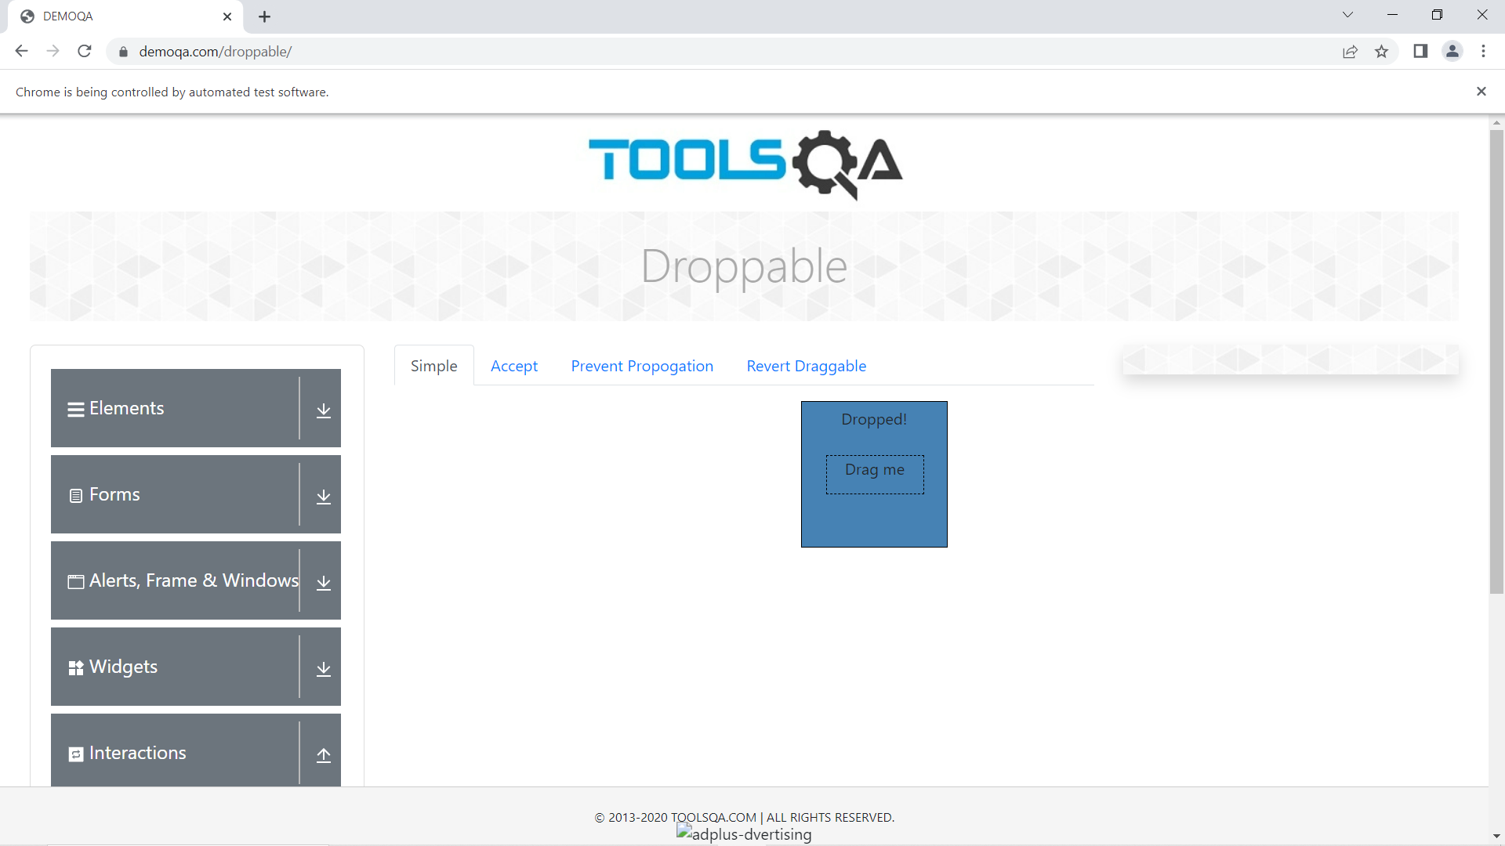

**EX2**

package com.Pack1;

import org.openqa.selenium.By;

import org.openqa.selenium.WebDriver;

import org.openqa.selenium.WebElement;

import org.openqa.selenium.chrome.ChromeDriver;

import org.openqa.selenium.chrome.ChromeOptions;

import org.openqa.selenium.interactions.Actions;

import io.github.bonigarcia.wdm.WebDriverManager;

public class day52 {

public static void main(String[] args) {

WebDriverManager.chromedriver().setup();

ChromeOptions co=new ChromeOptions();

co.addArguments("--remote-allow-origins=*");

WebDriver driver=new ChromeDriver(co);

driver.get("https://jqueryui.com/droppable/");

driver.switchTo().frame(0);

Actions a=new Actions(driver);

WebElement source_ele=driver.findElement(By.id("draggable"));

WebElement dest_ele=driver.findElement(By.id("droppable"));

a.clickAndHold(source_ele).release(dest_ele).build().perform();

a.dragAndDrop(source_ele, dest_ele).build().perform();

}

}

**OUTPUT:**

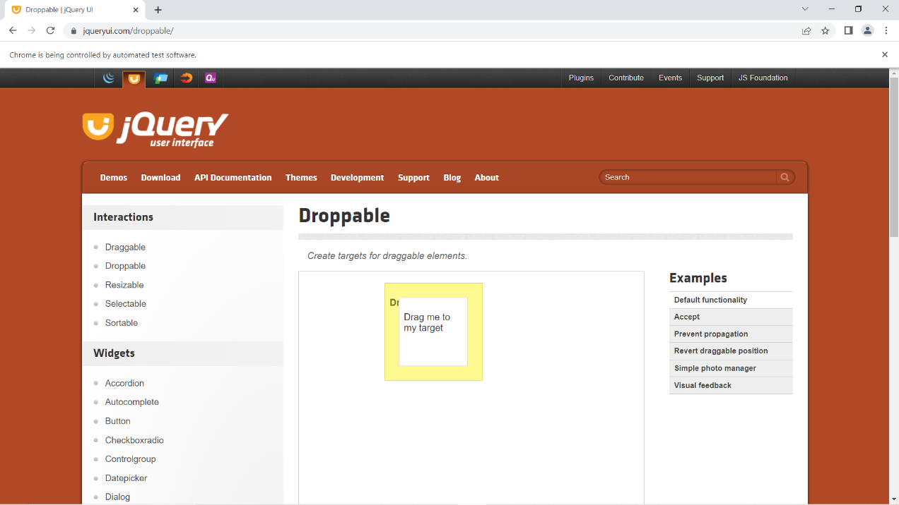

**EX3**

package com.Pack1;

import org.openqa.selenium.By;

import org.openqa.selenium.JavascriptExecutor;

import org.openqa.selenium.WebDriver;

import org.openqa.selenium.WebElement;

import org.openqa.selenium.chrome.ChromeDriver;

import org.openqa.selenium.chrome.ChromeOptions;

import io.github.bonigarcia.wdm.WebDriverManager;

public class ex3 {

public static void main(String[] args) throws InterruptedException {

WebDriverManager.chromedriver().setup();

ChromeOptions co=new ChromeOptions();

co.addArguments("--remote-allow-origins=*");

WebDriver driver=new ChromeDriver(co);

driver.get("https://demo.opencart.com/index.php?route=checkout/voucher&language=en-gb");

WebElement rname=driver.findElement(By.xpath("//*[@id=\"input-to-name\"]"));

rname.sendKeys("Dhakshinya");

WebElement remail=driver.findElement(By.xpath("//*[@id=\"input-to-email\"]"));

remail.sendKeys("dhakshinyaca@gmail.com");

WebElement yname=driver.findElement(By.xpath("//*[@id=\"input-from-name\"]"));

yname.sendKeys("Keerthana");

WebElement ymail=driver.findElement(By.xpath("//*[@id=\"input-from-email\"]"));

ymail.sendKeys("keerthana@gmail.com");

WebElement button=driver.findElement(By.xpath("//*[@id=\"input-theme-6\"]"));

button.click();

JavascriptExecutor js=(JavascriptExecutor)driver;

js.executeScript("window.scrollBy(0,250)","");

Thread.sleep(3000);

WebElement message=driver.findElement(By.xpath("//*[@id=\"input-message\"]"));

message.sendKeys("Hi");

WebElement amount=driver.findElement(By.xpath("//*[@id=\"input-amount\"]"));

amount.sendKeys("1");

WebElement button1=driver.findElement(By.xpath("//*[@id=\"form-voucher\"]/div[8]/div/div/input"));

button1.click();

}

}

**OUTPUT:**

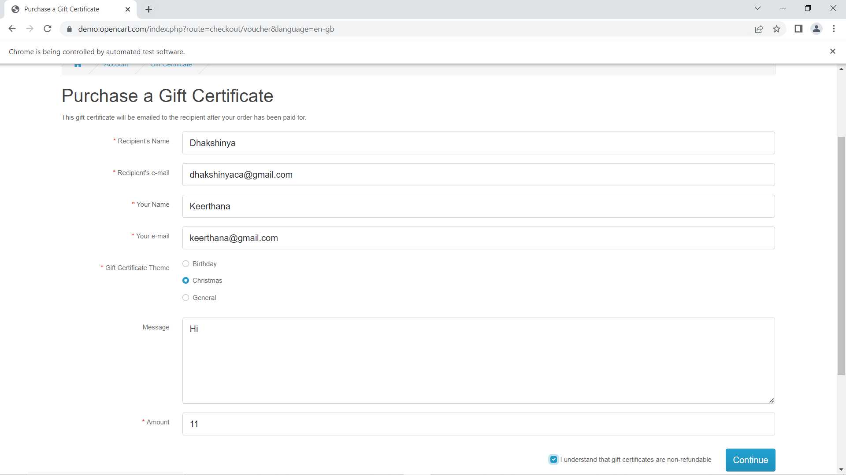

**EX4**

**package** Pack1;

**import** org.openqa.selenium.By;

**import** org.openqa.selenium.JavascriptExecutor;

**import** org.openqa.selenium.Keys;

**import** org.openqa.selenium.WebDriver;

**import** org.openqa.selenium.WebElement;

**import** org.openqa.selenium.chrome.ChromeDriver;

**import** org.openqa.selenium.chrome.ChromeOptions;

**import** io.github.bonigarcia.wdm.WebDriverManager;

**public** **class** ex4 {

**public** **static** **void** main(String[] args) **throws** InterruptedException {

WebDriverManager.*chromedriver*().setup();

ChromeOptions co=**new** ChromeOptions();

co.addArguments("--remote-allow-origins=*");

WebDriver driver=**new** ChromeDriver(co);

driver.get("https://www.abhibus.com/bus-ticket-booking");

WebElement fname=driver.findElement(By.*id*("source"));

fname.sendKeys("COIMBATORE",Keys.***ENTER***);

Thread.*sleep*(3000);

fname.sendKeys(Keys.***ENTER***);

WebElement dname=driver.findElement(By.*id*("destination"));

dname.sendKeys("ERODE",Keys.***ENTER***);

Thread.*sleep*(3000);

dname.sendKeys(Keys.***ENTER***);

WebElement tname=driver.findElement(By.*xpath*("//*[@id=\"datepicker1\"]"));

tname.click();

JavascriptExecutor js=(JavascriptExecutor)driver;

js.executeScript("arguments[0].setAttribute('value','04-5-2023')",tname);

WebElement search=driver.findElement(By.*xpath*("//*[@id=\"seo_search_btn\"]"));

search.click();

}

}

**OUTPUT:**

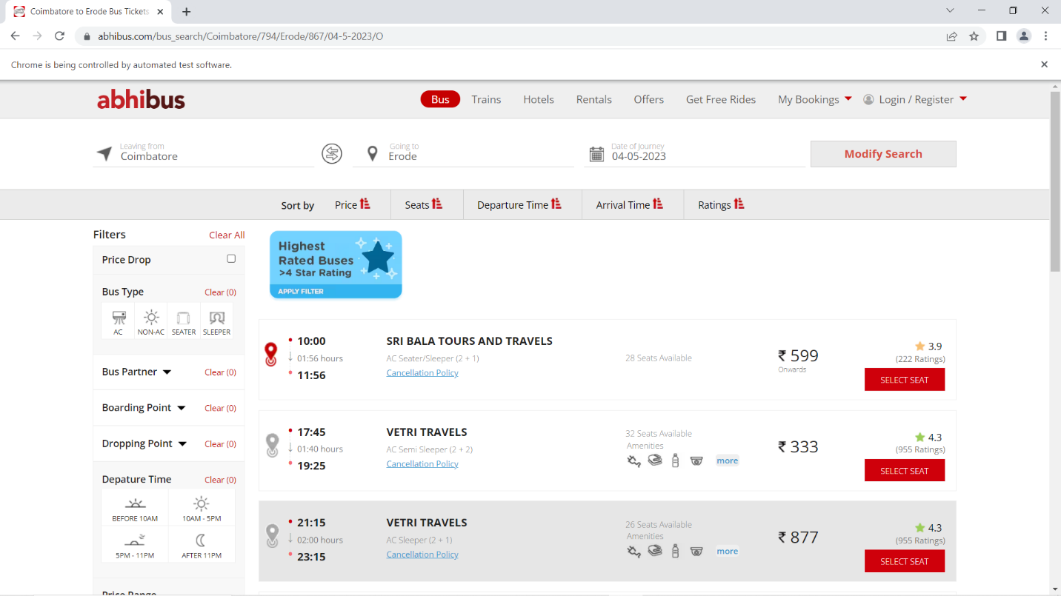

**EX5**

**package** Pack1;

**import** java.awt.Window;

**import** org.openqa.selenium.By;

**import** org.openqa.selenium.Keys;

**import** org.openqa.selenium.WebDriver;

**import** org.openqa.selenium.WindowType;

**import** org.openqa.selenium.chrome.ChromeDriver;

**import** org.openqa.selenium.chrome.ChromeOptions;

**import** io.github.bonigarcia.wdm.WebDriverManager;

**public** **class** ex5 {

**public** **static** **void** main(String[] args) {

WebDriverManager.*chromedriver*().setup();

ChromeOptions co=**new** ChromeOptions();

co.addArguments("--remote-allow-origins=*");

WebDriver driver=**new** ChromeDriver(co);

driver.get("https://www.google.com");

driver.manage().window().maximize();

driver.findElement(By.*name*("q")).sendKeys("Apple");

driver.findElement(By.*name*("q")).sendKeys(Keys.***ENTER***);

String parent=driver.getWindowHandle();

System.***out***.println(parent);

System.***out***.println(driver.getTitle());

driver.switchTo().newWindow(WindowType.***TAB***);

driver.get("https://google.com");

driver.manage().window().maximize();

driver.findElement(By.*name*("q")).sendKeys("Selenium");

driver.findElement(By.*name*("q")).sendKeys(Keys.***ENTER***);

System.***out***.print("\n"+driver.getWindowHandle());

System.***out***.println(driver.getTitle());

driver.switchTo().newWindow(WindowType.***TAB***);

driver.get("https://google.com");

driver.manage().window().maximize();

driver.findElement(By.*name*("q")).sendKeys("Cucumber");

driver.findElement(By.*name*("q")).sendKeys(Keys.***ENTER***);

System.***out***.print("\n"+driver.getWindowHandle());

System.***out***.println(driver.getTitle());

}

}

**OUTPUT:**

